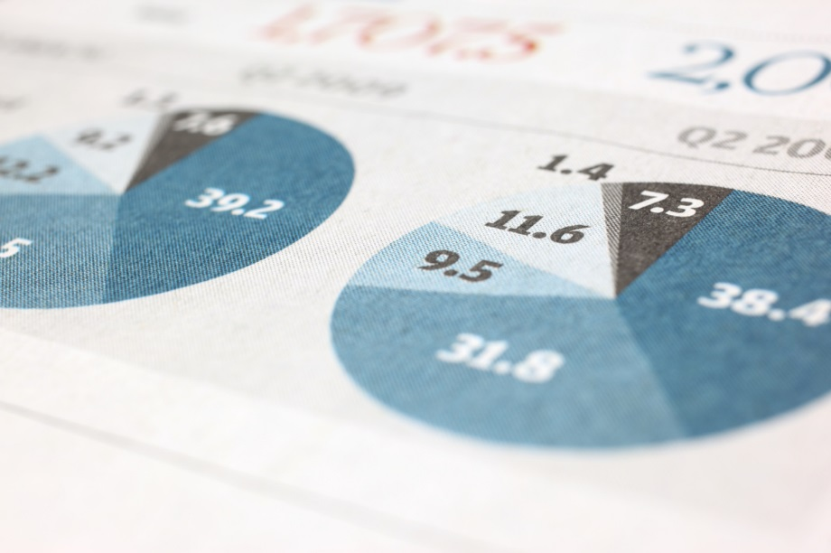

|  |
| --- |
|  |
| **Brazilian E-Commerce Public Dataset by Olist**  Analysis Report |
|  |

|  |  |  |
| --- | --- | --- |
| Ankit Narang | 10/27/20 |  |